 Health Partners Plans
Imprinted and Embroidered Apparel
For ordering online go to: tuttlemarketing/store.com
Select: Business; Select: Health Partners Plans from drop down list.
A full description of each item can be found on the online store

Item Description Quantity Size Color Total Cost
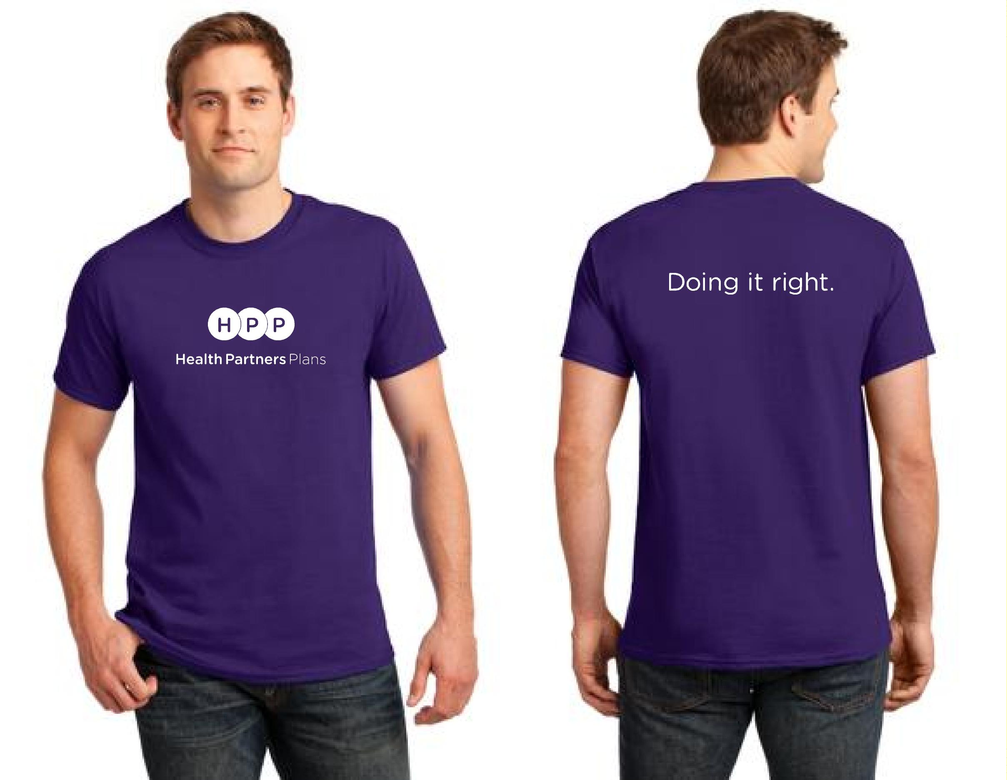 | Short Sleeve Tee  100% Cotton Tee  Color: Purple  Size: Adult: S-5XL  (Add: $2.00/ 2XL-5XL)  Price: $10.00
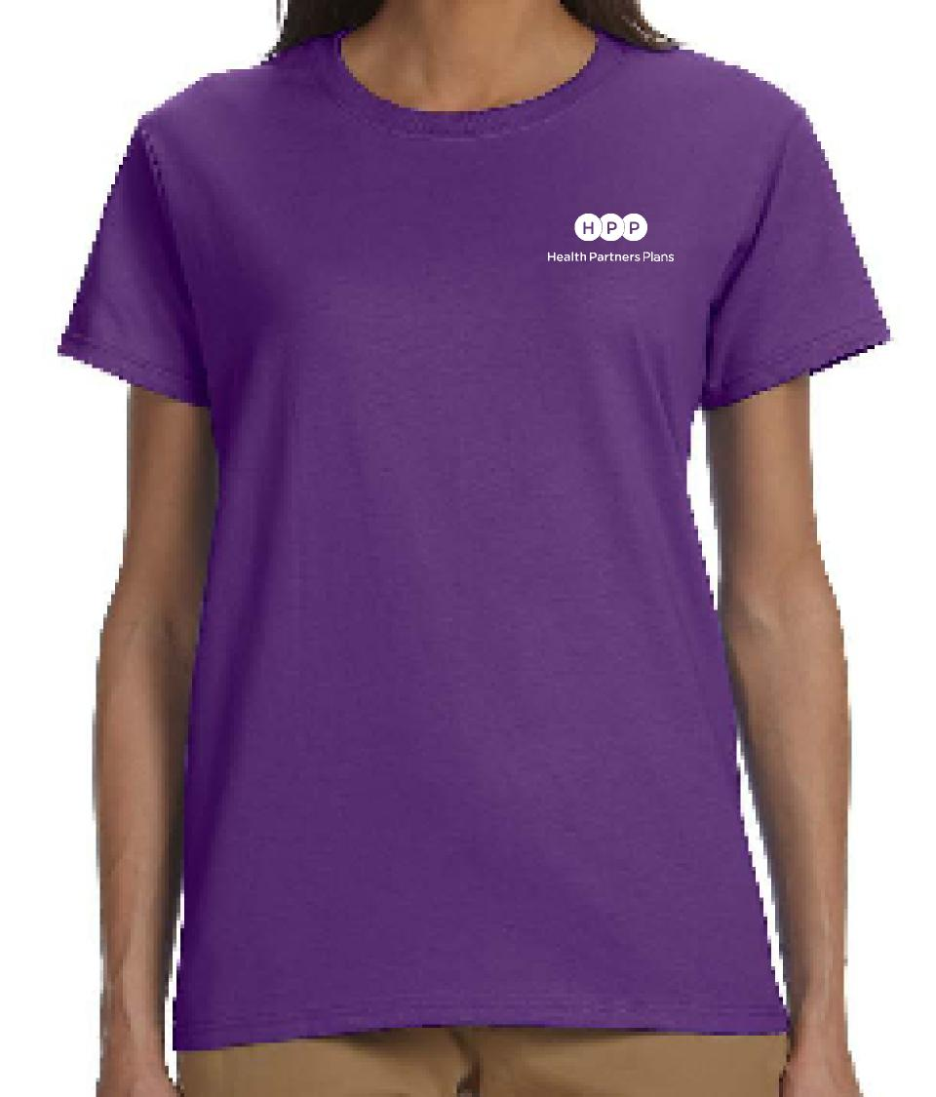 | Ladies Short Sleeve Tee  100% Cotton Tee  Color: Purple  Size: Adult: XS-3XL  (Add: $2.00/2XL; $3.00/3XL)  Price: $16.50
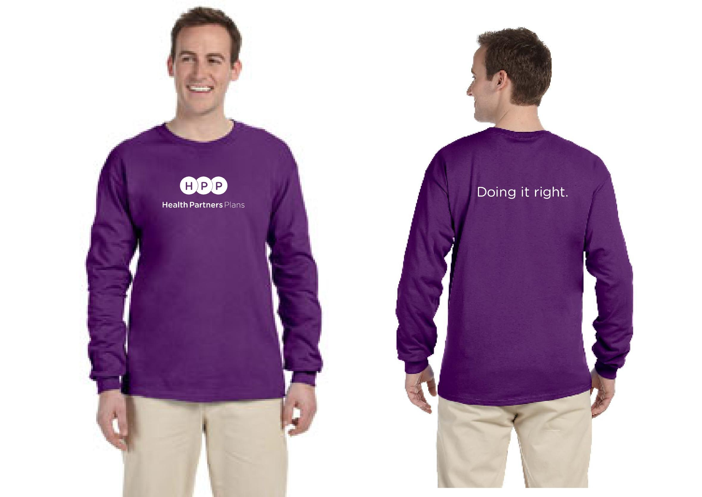 | Men’s Long Sleeve Tee  100% Cotton Tee  Color: Purple  Men’s Sizes: S-5XL  (Add: $2.00/2XL-5XL)  Price: $13.50
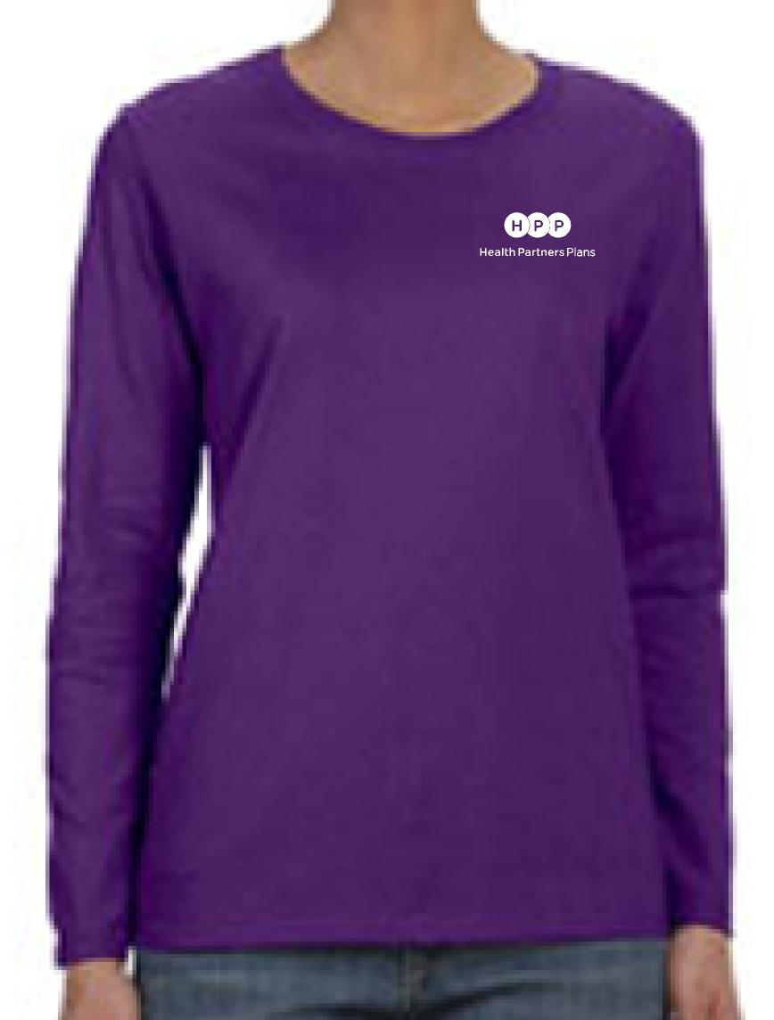 | Ladies Long Sleeve Tee  100% Cotton Tee  Color: Purple  Ladies Sizes: S-3XL  (Add: $2.00/2XL; $3.00/3XL)  Price: $19.00
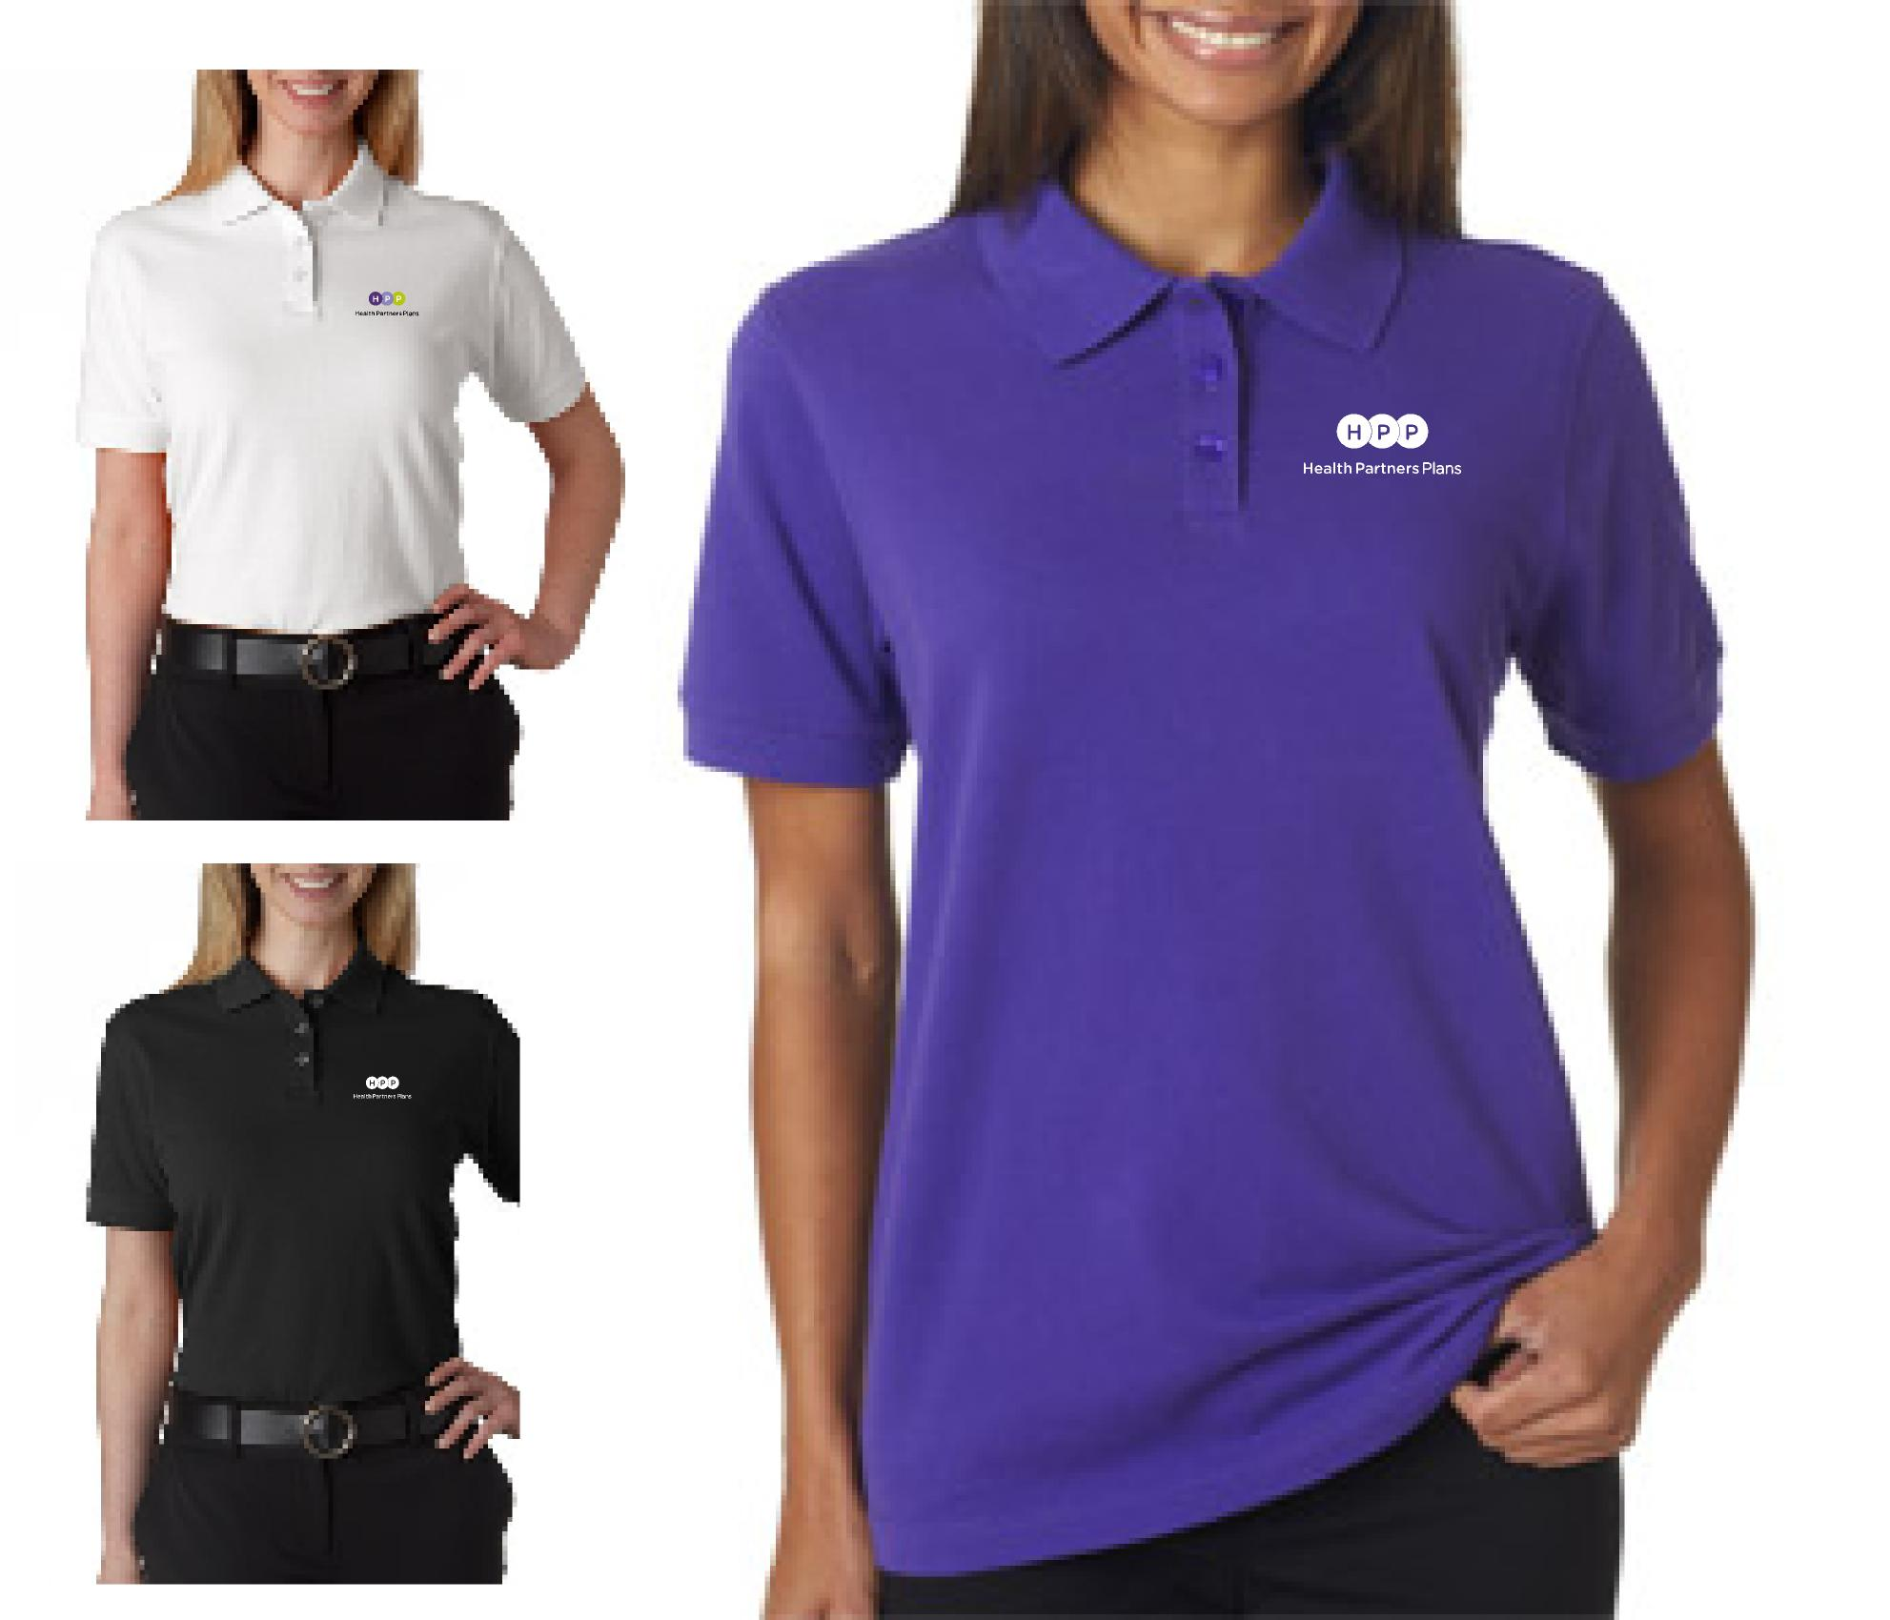 | Ladies Short Sleeve Polo  100% Cotton Pique  Color: Purple, White, Black  Ladies Sizes: XS-3XL  (Add: $2.00/2XL; $3.00/3XL)  Price: 22.50
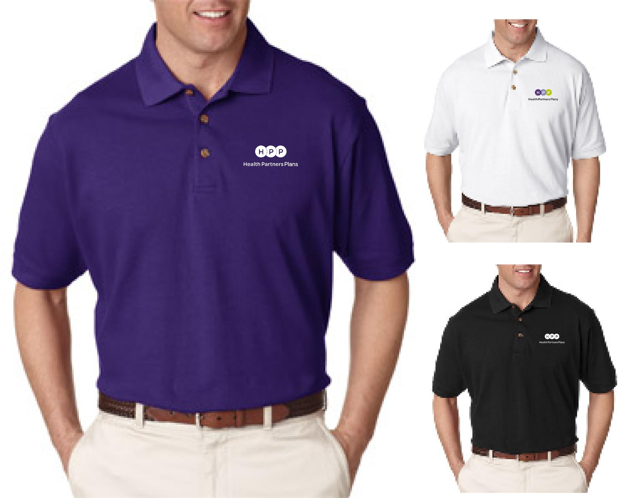 | Men’s Short Sleeve Polo  100% Cotton Pique  Color: Purple, White, Black  Men’s Sizes: S-6XL  (Add: $2.00/2XL; $3.00/3XL; $4.00/4XL; $5.00/5XL; $6.00/6XL)  Price: $22.50
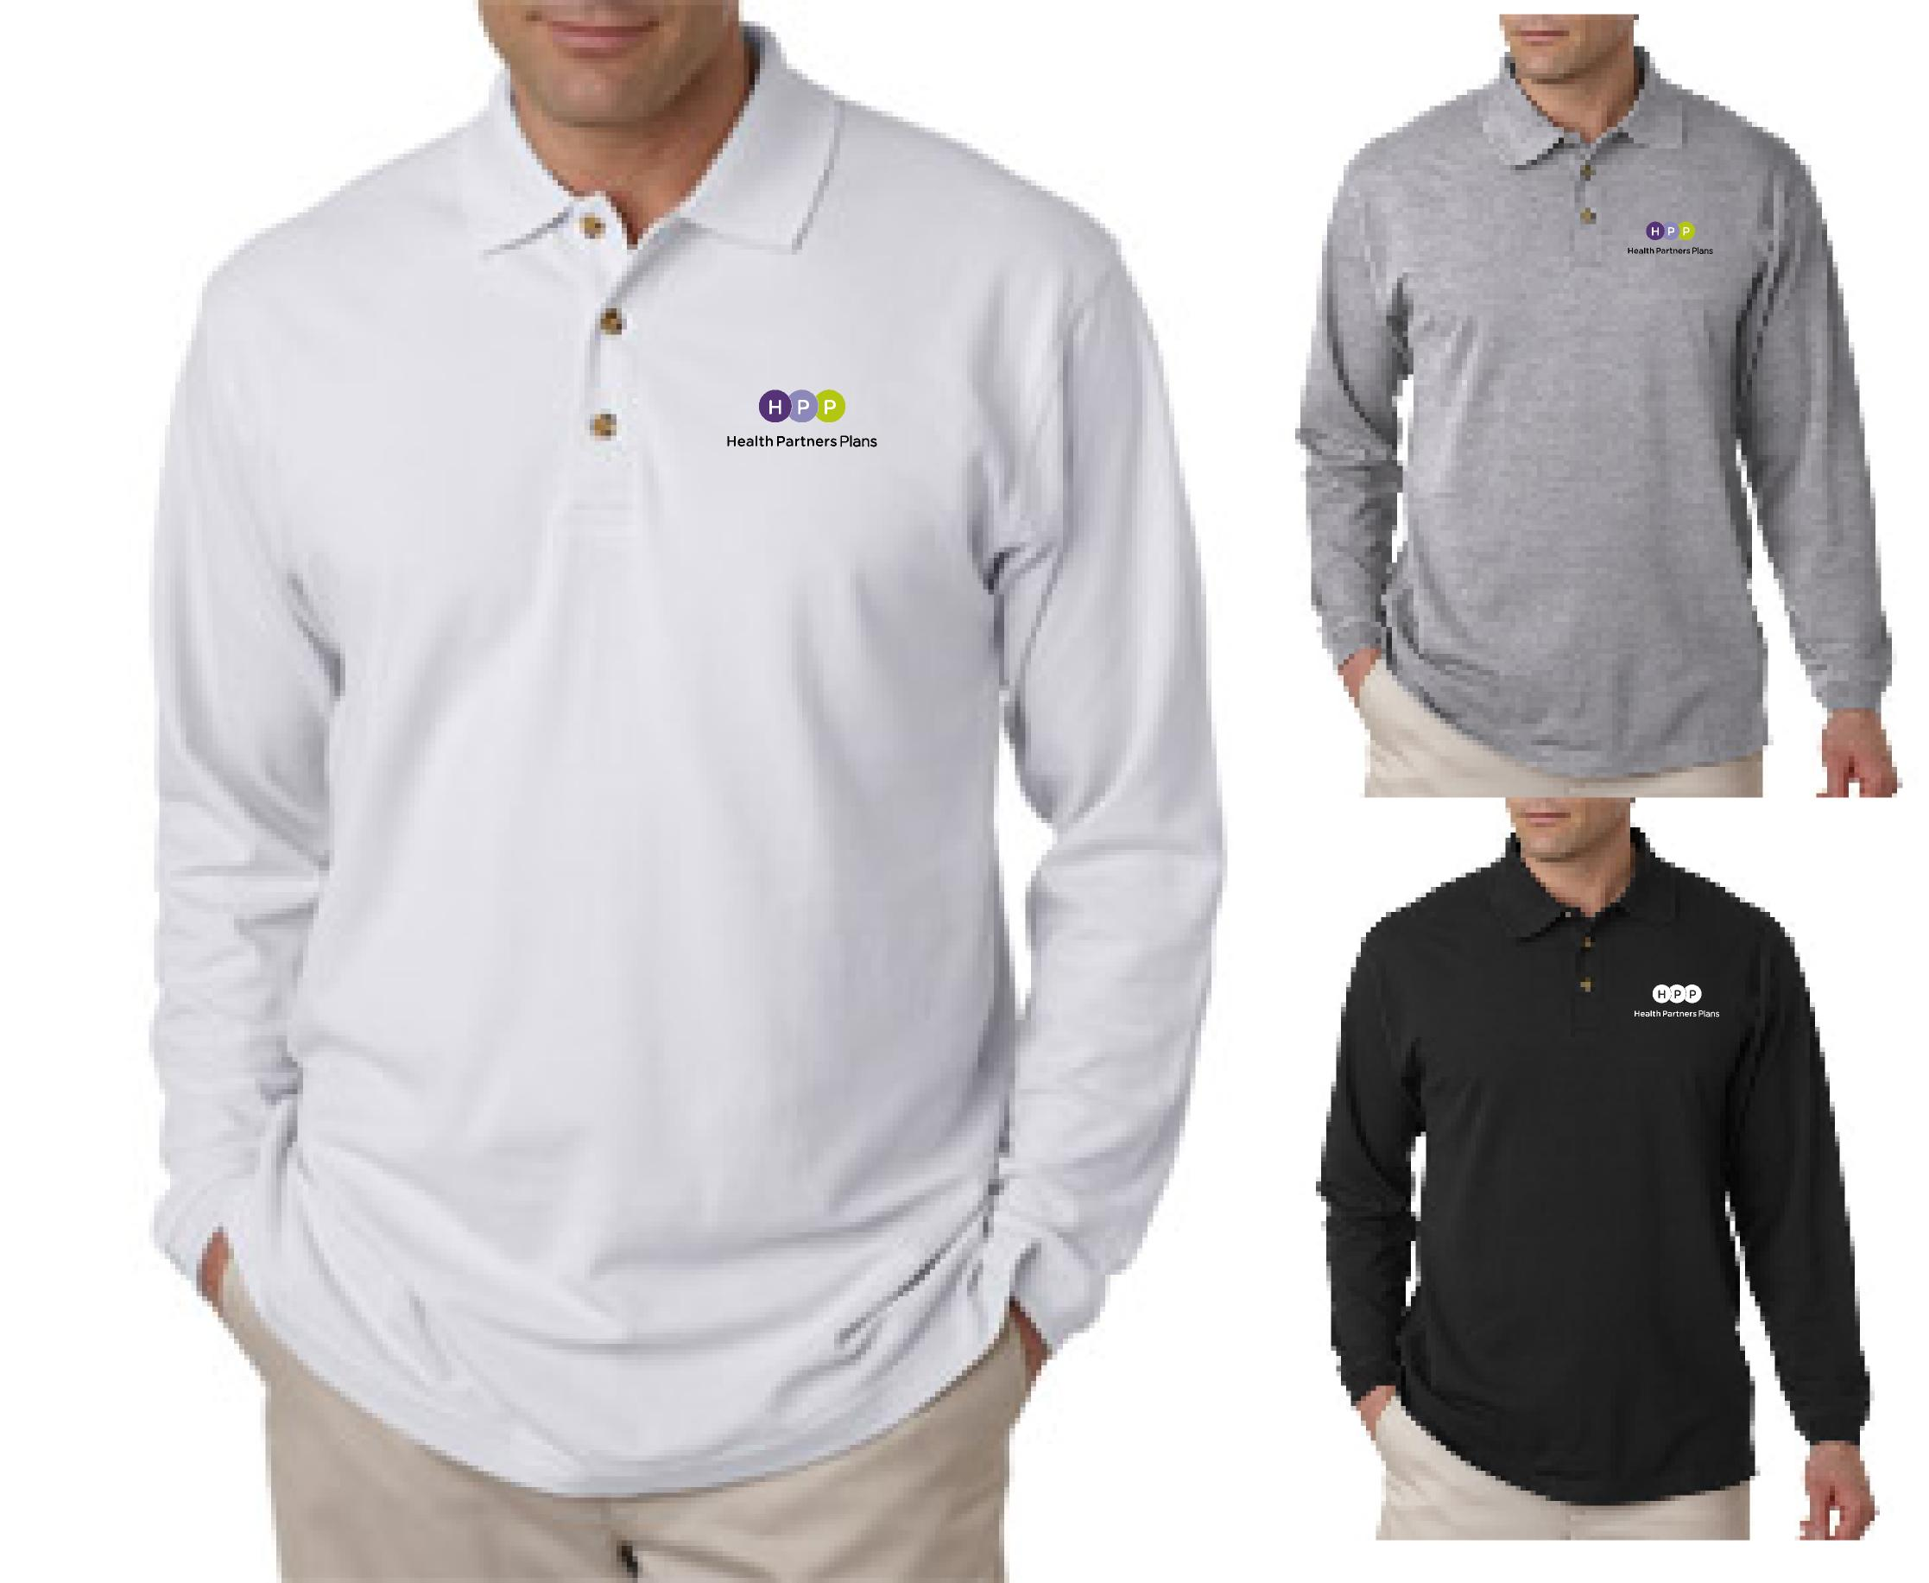 | Men’s Long Sleeve Polo  100% Cotton Pique  Color: Black, White, Heather Grey  Men’s Sizes: S-4XL  (Add: $2.00/2XL; $3.00/3XL; $4.00/4XL)  Price: $26.50
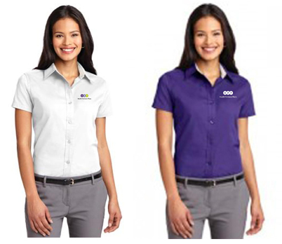 | Ladies Short Sleeve Button Down Shirt  50/45 Cotton/Polyester; Tapered Fit  Color: White or Purple  Ladies Sizes: XS-6XL  (Add: $2.00/2XL; $3.00/3XL; $4.00/4XL; $5.00/5XL; $6.00/6XL)  Price: $29.00
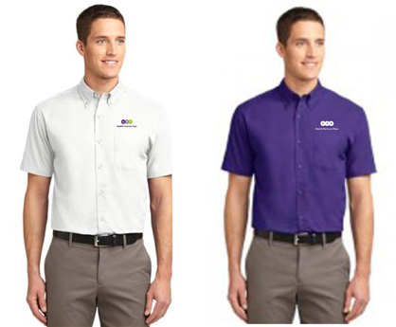 | Men’s Short Sleeve Button Down Shirt  50/45 Cotton/Polyester  Color: White or Purple  Men’s Sizes: XS-6XL  (Add: $2.00/2XL; $3.00/3XL; $4.00/4XL; $5.00/5XL; $6.00/6XL)  Price: $29.00
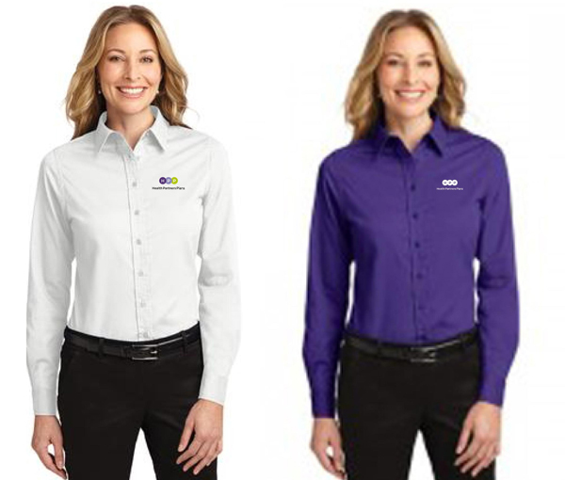 | Ladies Long Sleeve Button Down Shirt  50/45 Cotton/Polyester; Tapered Fit  Color: White or Purple  Ladies Sizes: XS-6XL  (Add: $2.00/2XL; $3.00/3XL; $4.00/4XL; $5.00/5XL; $6.00/6XL)  Price: $29.00
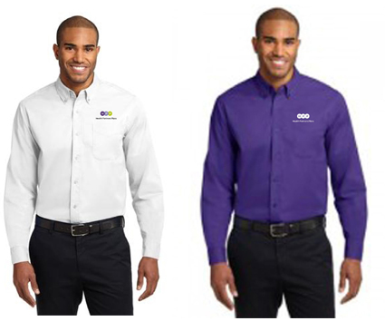 | Men’s Long Sleeve Button Down Shirt  50/45 Cotton/Polyester  Color: White or Purple  Ladies Sizes: XS-6XL  (Add: $2.00/2XL; $3.00/3XL; $4.00/4XL; $5.00/5XL; $6.00/6XL)  Price: $29.00
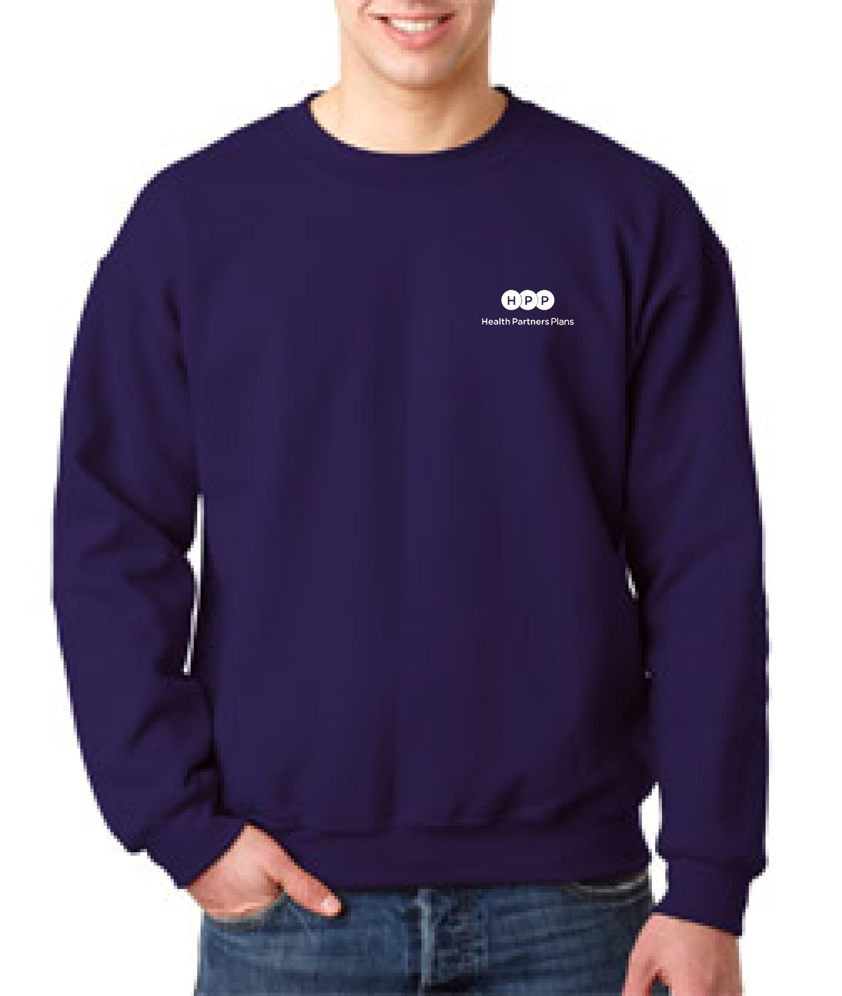 | Crew Neck Sweatshirt  50/50 Cotton/Polyester  Color: Purple  Adult Sizes: S-3XL  (Add: $2.00/2XL; $3.00/3XL)  Price: $21.00
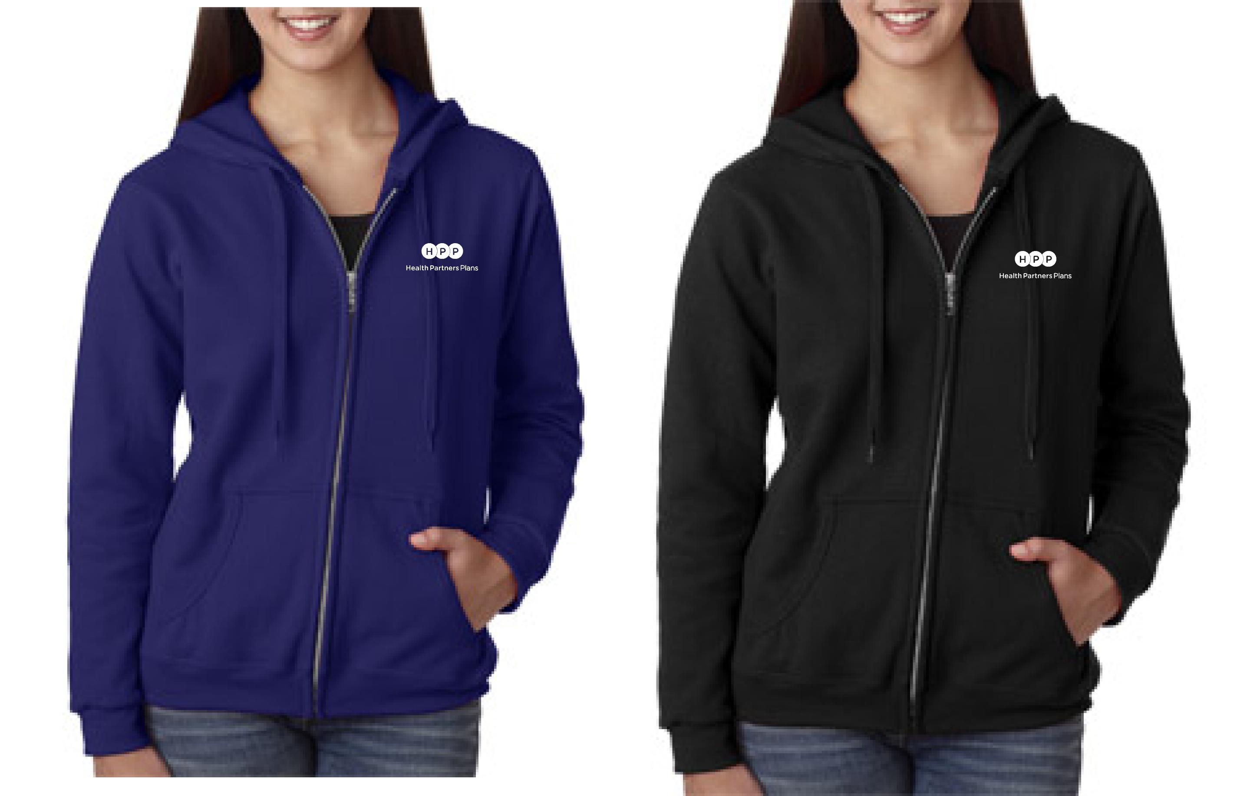 | Ladies Full Zip Hooded Sweatshirt  50/50 Cotton/Polyester  Color: Purple or Black  Ladies Sizes: S-5XL  (Add: $2.00/2XL; $3.00/3XL; $4.00/4XL; $5.00/5XL)  Price: $30.00
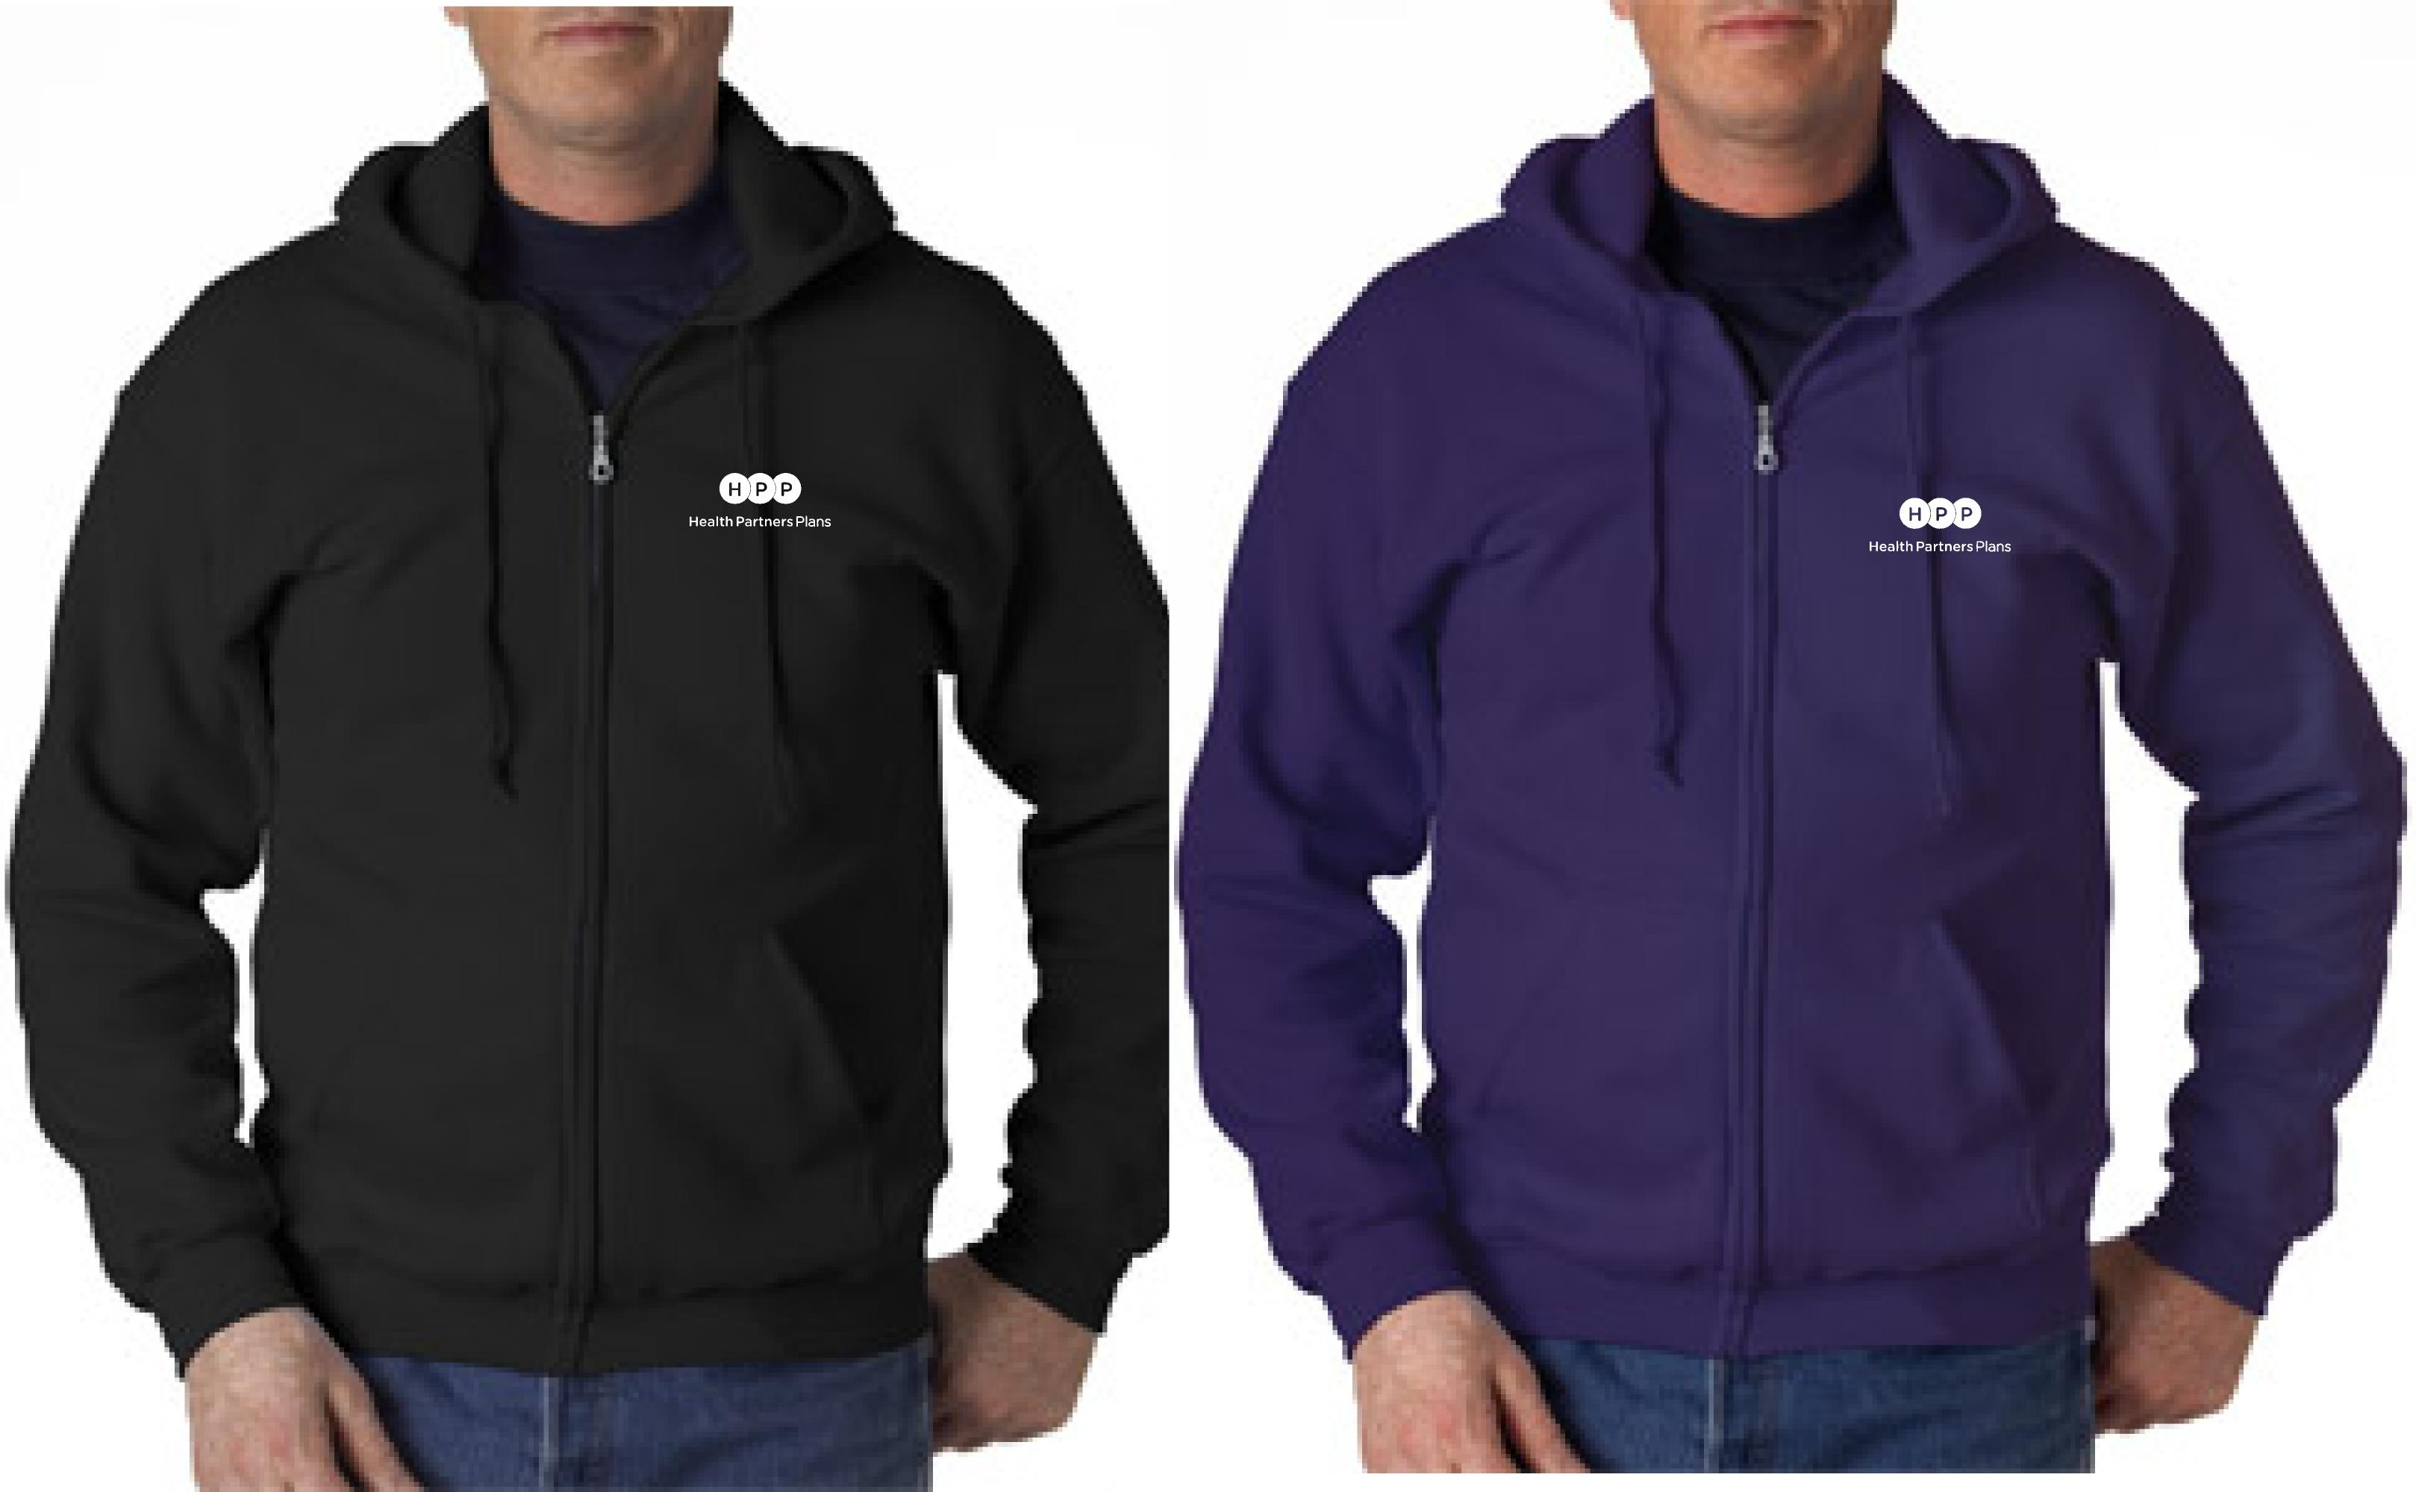 | Men’s Full Zip Hooded Sweatshirt  50/50 Cotton/Polyester  Color: Purple or Black  Men’s Sizes: S-5XL  (Add: $2.00/2XL; $3.00/3XL; $4.00/4XL; $5.00/5XL)  Price: $30.00
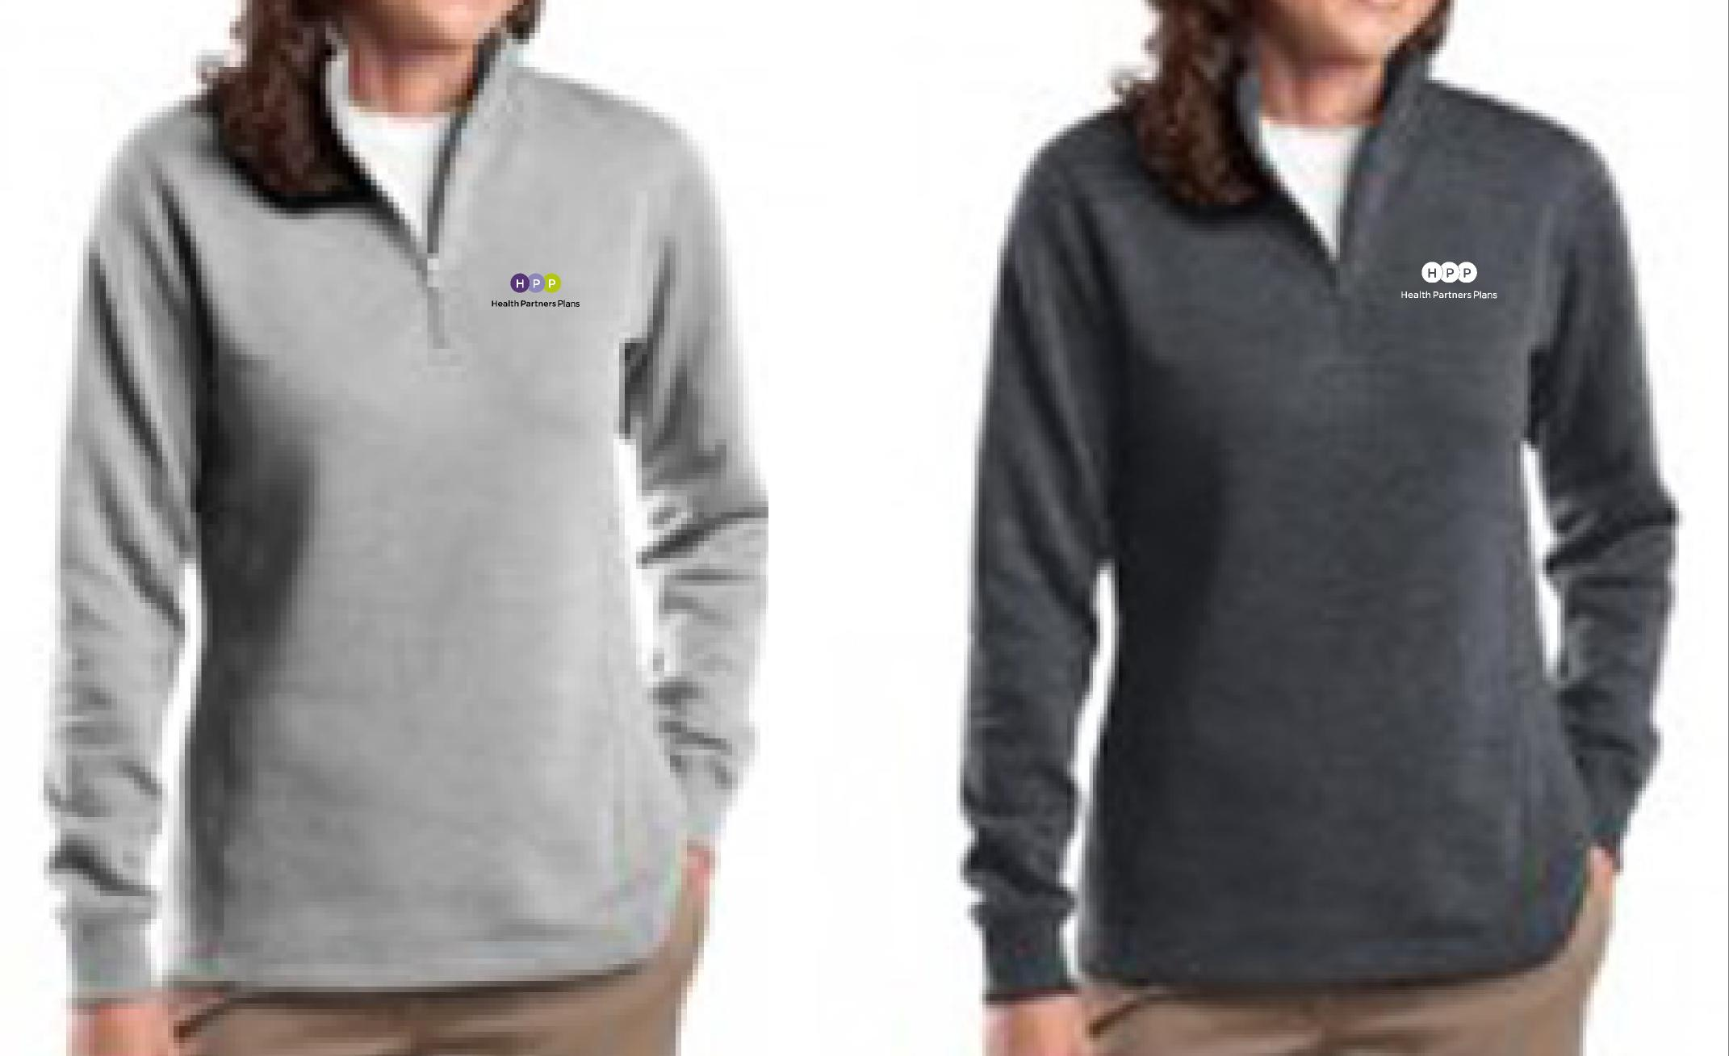 | Ladies ¼ Zip Pullover Sweatshirt  65/35 Cotton/Polyester; Tapered Fit  Color: Lt. Grey or Dark Grey  Ladies Sizes: XS-4XL  (Add: $2.00/2XL; $3.00/3XL; $4.00/4XL)  Price: $33.00
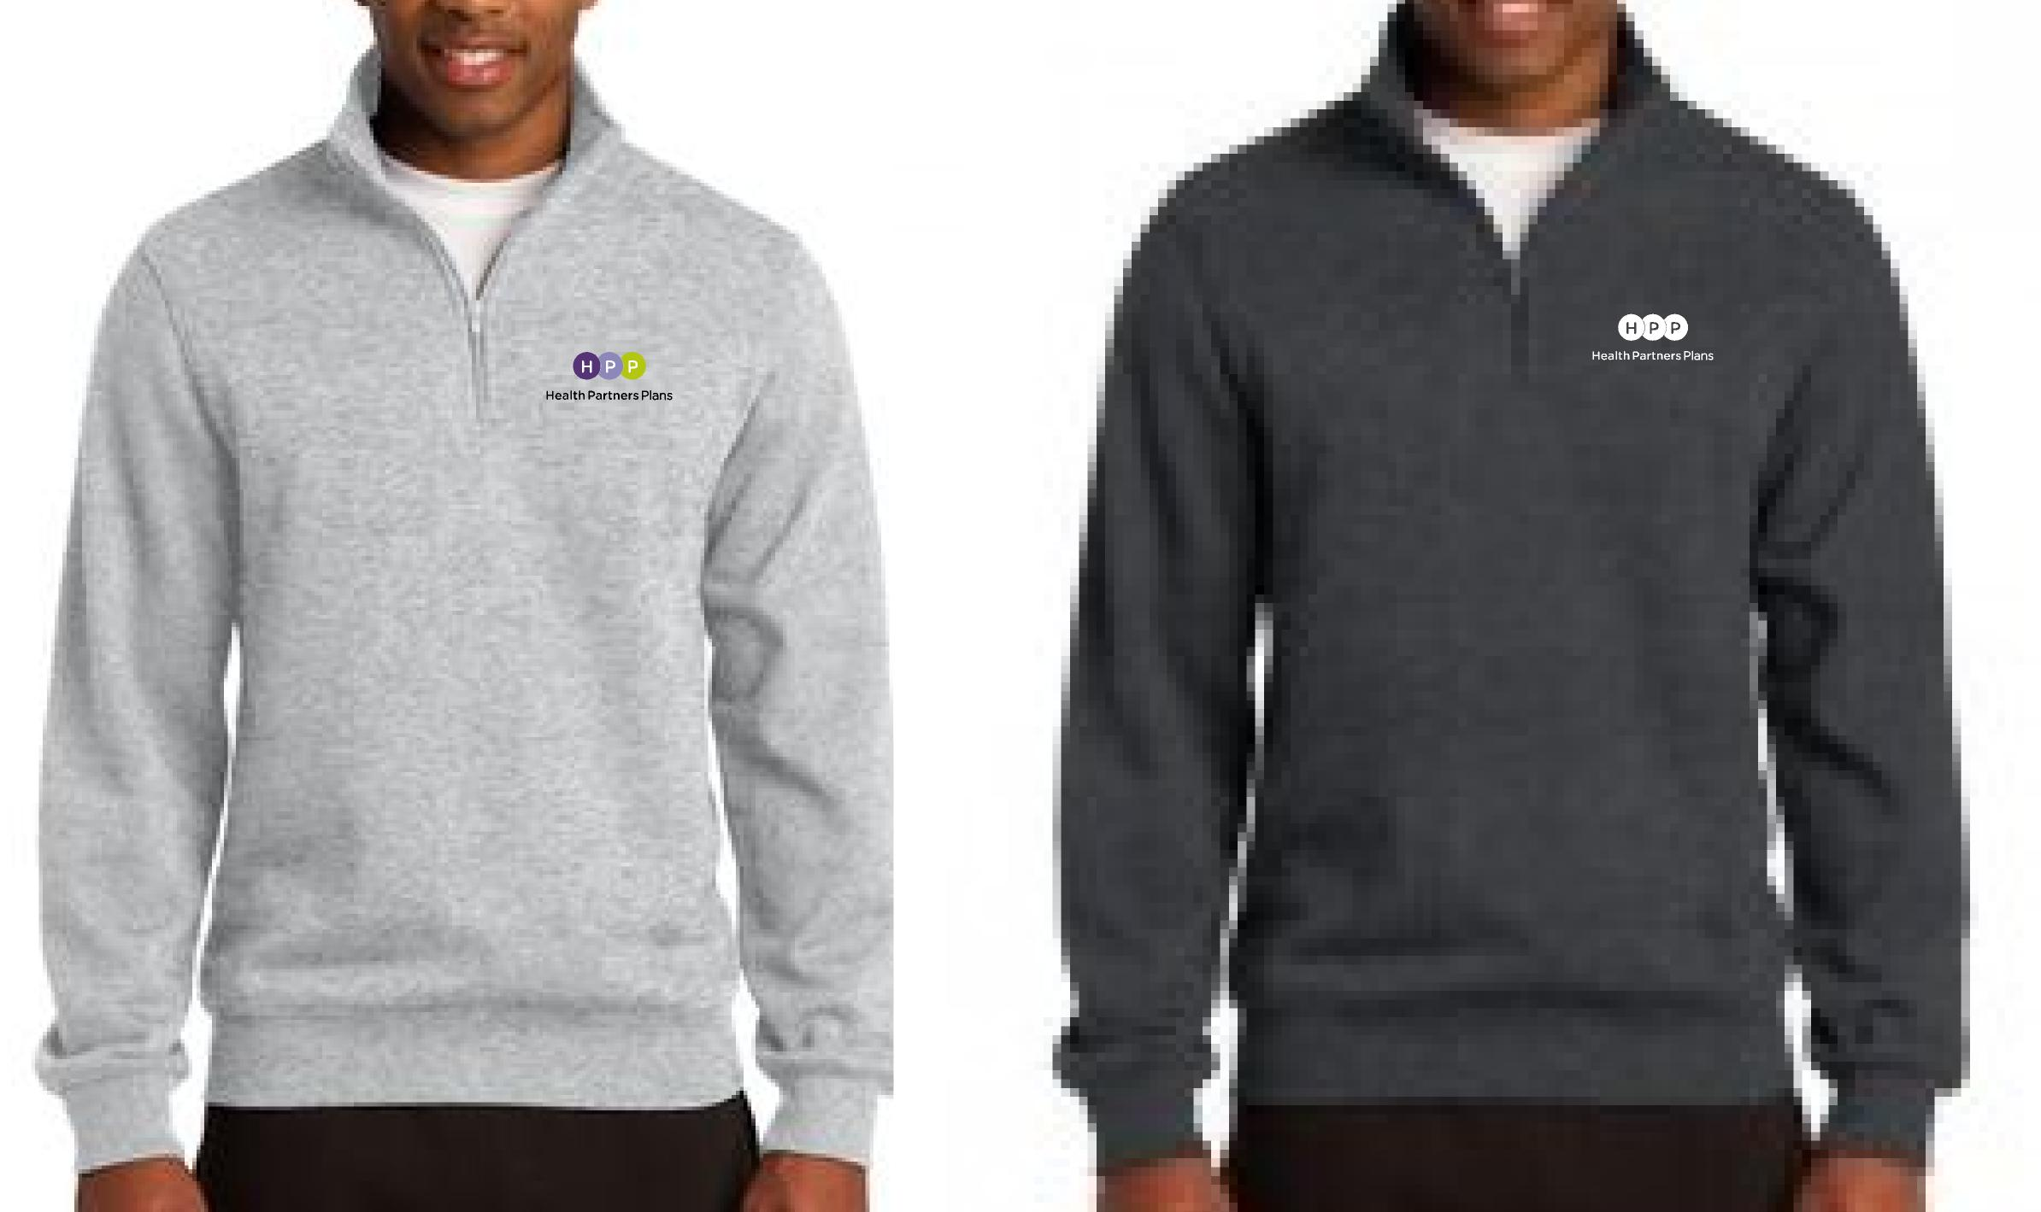 | Men’s ¼ Zip Pullover Sweatshirt  65/35 Cotton/Polyester; Tapered Fit  Color: Lt. Grey or Dark Grey  Men’s Sizes: XS-4XL  (Add: $2.00/2XL; $3.00/3XL; $4.00/4XL)  Price: $33.00
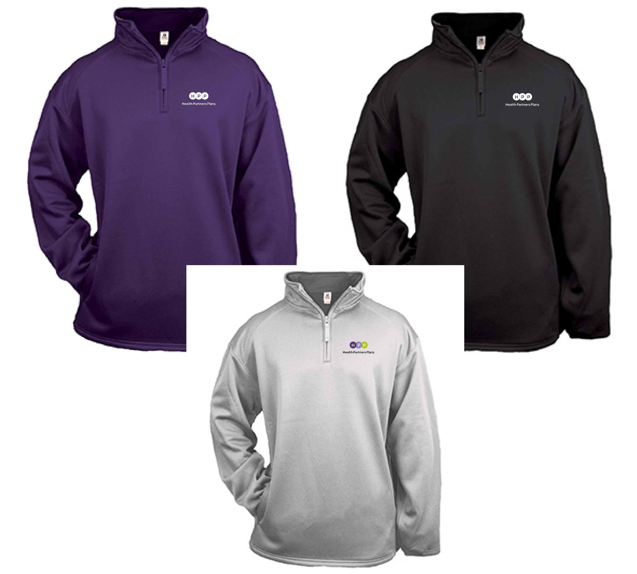 | ¼ Zip Performance Pullover Sweatshirt  100% polyester moisture management fabric  Color: Purple, Black, Silver  Men’s Sizes: S-3XL  (Add: $2.00/2XL; $3.00/3XL; $4.00/4XL)  Price: $43.00
Freight Charges | Orders are shipped UPS (no PO boxes) Include shipping address below | Add Freight:  - Item: $ 9.75  - Items: $10.50  - Items: $11.50  - Items: $13.00
Total Due |  | $
Make checks payable to: “Tuttle Marketing Services”
Name:________________________________________________________________________________________________
Address:______________________________________________________________________________________________
City:_______________________________________________ State:_______________ Zip:_____________________
Phone:______________________________________________ Email:___________________________________________
Mail Order to: Jeanne Reith
Tuttle Marketing Services
1224 Gail Road
West Chester, PA 19380
Questions, contact Jeanne at: 610-430-7432 or email: jeanne@tuttlemarketing.com

